1. new { TourId = booking.TourId, Name = booking.Name, Email = booking.Email, Transport = booking.Transport });

changed booking.name to booking.Name in BookingRepository.cs

1. public string Description { get; set; }

added a semicolon after set (set;) in Tour.cs

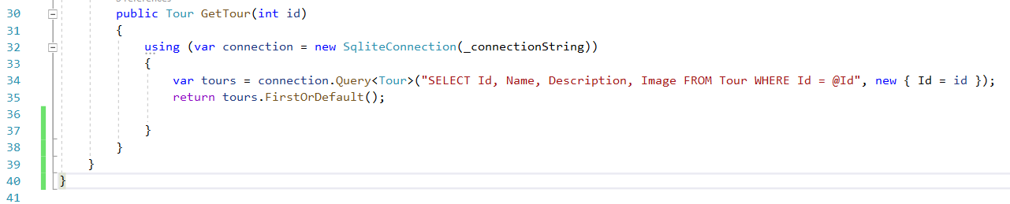

Added a closing curly bracket in ToursRepository.cs

1. public static void Main(string[] args)

Changed spelling of Maiin to Main

1. Uncommented the code in Index.cshtml which was between @\* \*@

Once the errors are removed, the output is as follows:

